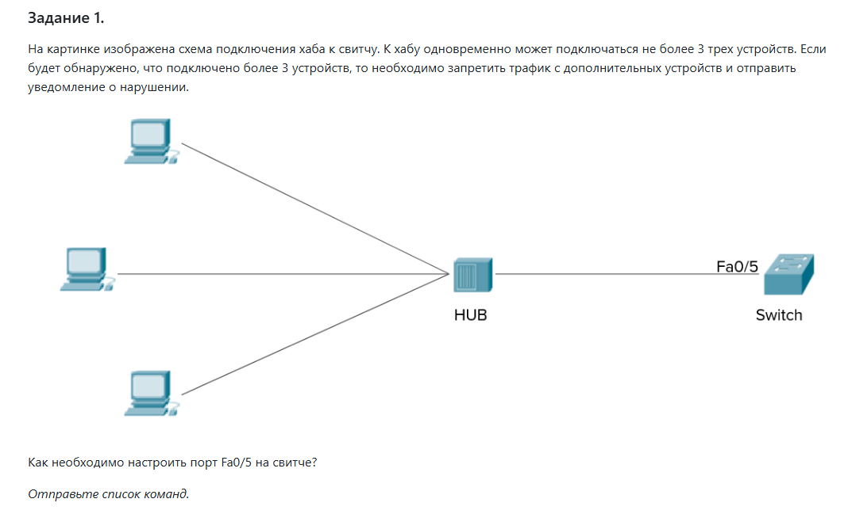

interface FastEthernet0/5

switchport mode access

switchport port-security

switchport port-security maximum 3

switchport port-security violation restrict

switchport port-security mac-address sticky

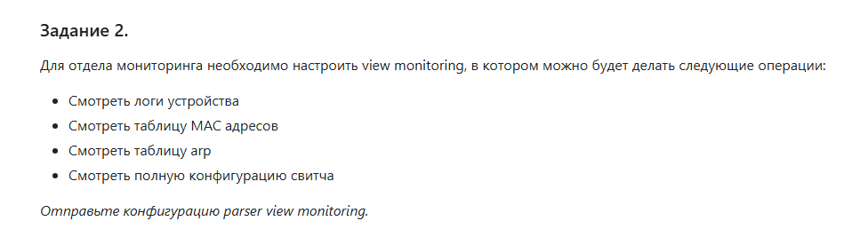

parser view monitoring

secret cisco

commands exec include show logging

commands exec include show mac address-table

commands exec include show arp

commands exec include show running-config